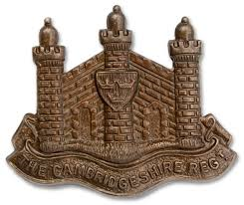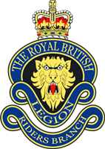
THE ROYAL BRITISH LEGION RIDERS BRANCH
Ride-Out and Service of Remembrance on Saturday 29th October 2016,
to honour Pte’s Collins, Whybrow and Harrison, The Cambridgeshire Regiment

Assembly
10:00 Riders Branch members begin to arrive at the Riders RV, Tesco Milton car park, Cambridge CB24 6AY
10:30 Riders depart Tesco for Cambridge City Cemetery, Newmarket Rd, Cambridge CB5 8PE
10:30 All attendees to be assembled at the Cemetery (enter via Ditton Lane, B1047)
10:40 Riders arrive at the Cemetery
10:45 VIPs arrive at the Cemetery
10:55 Parade & Riders formed up at the graveside
Act of Remembrance
11:00 Introduction
Reading Regimental Collect
Prayer
Parade brought to attention. Civilians to remove headdress
Reading of names A brief history of each soldier will be read out by members of the project committee
Last Post Bugler will sound Last Post
The exhortation Read by Mr Nick Simms
The Response “We will remember them”
The silence Parade will remain silent for 2 minutes
Reveille Bugler sounds: "Reveille"
after which the parade is stood at ease. Civilians may replace headdress
Commitment Read by whole ‘Cambs 876 Remembered’ Committee
Prayer
Placing of wreath(s) and poppy cross

After the wreath party returns, the parade will be brought to attention. Civilians to remove headdress
National Anthem
Verse 1.  God save our gracious Queen  Long live our noble Queen  God save the Queen  Send her victorious  Happy and glorious  Long to reign over us  God save the Queen | Verse 2.  Thy choicest gifts in store  On her be pleased to pour  Long may she reign  May she defend our laws  And ever give us cause  To sing with heart and voice  God save the Queen
After which, Parade remains at attention. Civilians may replace headdress
Withdrawal
VIPs depart the Cemetery. Parade dismissed and attendees disperse.
All are invited to retire to Cambridgeshire Army Cadet Force Headquarters, Denny End Road, Waterbeach CB25 9QU
for light refreshments and a display of the Riders Branch Cambs 876 Remembered project.

